Word Search Fall
What does fall remind you of?
- Fall often reminds us of change and transition, as nature shifts from vibrant greens to warm hues of red, orange, and yellow. It evokes feelings of nostalgia, cozy gatherings, and the beauty of letting go, encouraging us to slow down and reflect on our own lives
- Get cozy and celebrate autumn things like: sweaters, chai, changing leaves, ready for it!

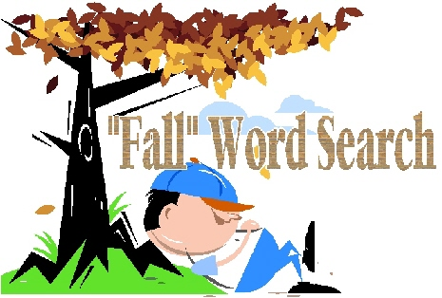

algebra |  | Art |  | band
Birdhouses |  | books |  | chilly
ClimbZone |  | colors |  | cool
debate |  | Dinosaur |  | drums
fans |  | fans |  | Farmers
field |  | football |  | helmet
hike |  | homework |  | HorrorHouse
LaurelLakes |  | Leaves |  | Library
Mansion |  | MARC |  | Market
math |  | Montpelier |  | Museums
orange |  | Parks |  | Patuxent
pencils |  | pens |  | plays
pumpkin |  | RaceTrack |  | rake
Research |  | Riverfront |  | ruler
rust |  | school |  | science
shows |  | study |  | teachers
teams |  | Tour |  | Visitors
volleyball |  | Walking |  | Wildlife
Need answer? Contact on Menu or CultivatingCommunityConn@gmail.com

Answers -

Word Search – Fall

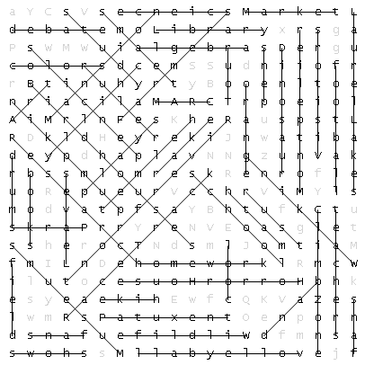

algebra |  | Art |  | band
Birdhouses |  | books |  | chilly
ClimbZone |  | colors |  | cool
debate |  | Dinosaur |  | drums
fans |  | fans |  | Farmers
field |  | football |  | helmet
hike |  | homework |  | HorrorHouse
LaurelLakes |  | Leaves |  | Library
Mansion |  | MARC |  | Market
math |  | Montpelier |  | Museums
orange |  | Parks |  | Patuxent
pencils |  | pens |  | plays
pumpkin |  | RaceTrack |  | rake
Research |  | Riverfront |  | ruler
rust |  | school |  | science
shows |  | study |  | teachers
teams |  | Tour |  | Visitors
volleyball |  | Walking |  | Wildlife

